**Design a game**

**Research**There are many games already in existence, and many genres. From First-Person Shooters such as *Call of Duty* and *Counter Strike*, to simple puzzle games like *Ferdy*, and horror games like *Five Nights at Freddy’s*, and some games blur the lines between the genres, such as *Portal*, a puzzle-solving, platformer and shooter game all rolled into one.

The three genres I will be looking at are FPS, real-time strategy, and puzzle-solving.

FPS  
An FPS (First-Person Shooter) is a type of first-person game revolving around shooting, often in a military setting. These games tend to have lots of different weapons, maps and are usually played multiplayer rather than campaign. It is the most popular type of game by far, and examples include *Call of Duty*, *Counter Strike: Ghost Operations*, *Battlefield* and *Splatoon*. The majority of these games have little or no campaign, but have millions of online players and fierce competitions to get onto the leader boards. Despite being in a military setting, FPS’s are generally not as violent as they are stereotyped to be, as they have few gore effects, do not portray combat realistically, and are entirely fictional.

Real-time strategy  
RTS games are similar to board games, except they are not turn-by-turn. Players act as a commander over their forces, which could be an army or dart-wielding monkeys (as in *Age of Empires* and *Balloon Tower Defence* respectively).

The player can tell troops where to go, build defences, re-route supply chains or position weapons to defeat an enemy. One type of real-time strategy game is a Tower defence game, in which the player can position some form of ‘tower’ – a unit that can attack from a fixed position – around a track (sometimes anywhere, sometimes only at certain points), which will then attack targets on the track autonomously (usually with a projectile, such as a gun or bow and arrow, depending on the setting). The player must position the right kind of tower in the right place, and manage resources such as money or ammunition.

Puzzle-solving  
Puzzle-solving games involve solving challenges according to a set of rules, usually involving pairing objects of some kind together, or moving something to a particular place. For example, it may require moving blocks out of the way to reach a goal, but the blocks can only move in one direction, or some obstacles are fixed in place, or the blocks join together when they touch. These kind of games are usually more casual and not played as seriously as other types of games.

Due to the nature of these games, they can be almost anything, so long as they require lots of thinking, rather than skill or luck, to win.

**P2 – Outline Ideas**My idea for a game is a combination of real-time strategy and puzzle-solving.

It would be a 2D top-down view, like early versions of GTA, and would involve navigating through simple mazes. However, an enemy will be moving around in the maze, and if the enemy catches the player then the game is over.

This game could be classed as puzzle solving as it involves navigating simple mazes, which is definitely a puzzle. The mazes could get more complex for each level.

It is also real time strategy, because there is the pressure of the approaching enemy. This means the player must solve the puzzle of the maze as well as reacting to the enemy in a skill-based way.

**M2 – Detailed Ideas**The object of the game is to guide a sprite (player-controlled character) through a maze. An enemy will move around the maze randomly, and the player must avoid the enemy.

The enemy will move randomly, rather than chasing the player. This is because it makes the game easier to program and test, and also requires less powerful hardware to run the game.  
The levels would be designed rather than computer-generated, again to reduce coding and testing time, but also to ensure that the maze is actually possible to solve.

The controls would probably just be the arrow keys (up, down, left and right) or the WASD keys for movement. Menus and other UI elements will be operated by the mouse.

**D2 – Thorough ideas**To counterpoint the simple nature of the game, the graphics will be detailed and complex, with animated character models and smooth movement mechanics. This will help the game to feel polished and high-quality, an important aspect of the user experience.

The simplest way to achieve realistic movement mechanics is to add acceleration and momentum to the movement. That is, when the character moves they start slowly and build up speed, and slide to a stop when the player changes direction. This is a fairly simple mathematical process, in which the speed varies at a set speed.

The graphics and art style will need to look good to offset the simple nature of the game. A game that uses this technique is *Ori and the Blind Forest*, a minimalistic 2D platformer that relies heavily on a hand-drawn art style and complex animations.

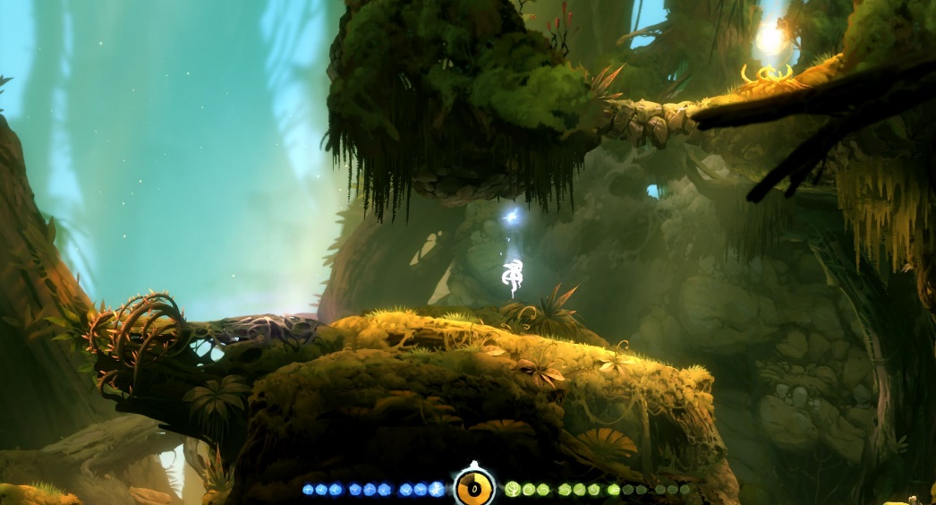

A screenshot from *Ori and the Blind Forest*, which looks very detailed despite being a simple game

As this game is top-down, it doesn’t need to use parallax (having the background move slower than the foreground) to simulate depth, but it could use other methods of adding realism, such as giving sprites shadows, as well as standing and running animations. These kinds of techniques have been used since the 90’s, so they are a tried and tested method of adding detail to an otherwise bland game.

The mazes will also have themes, or settings. They will emulate a real-world environment, such as a forest, office, or dungeon. Walls could be fallen trees, or rows of office cubicles. The enemy could also change to suit the theme. In a forest them it could be an animal, or in a setting on a plane it could be an angry passenger.

Another way of adding detail are ambient effects. These are simple looping background animations that don’t react to the gameplay, such as dust in sunbeams in *Ori*, or in this game there could be an effect relevant to the theme of the maze – if the maze is an office for example, there could be a potted plant that sways or some staff talking around a water cooler.